The Difference Between Content That Gets Views and Content That Makes Money
This is critical to understand: not all views are equal.
You can get 10 million views on content that makes you $0.
Or you can get 500,000 views on content that makes you $10,000.
The difference is who is watching and why they're watching.
Content that gets views but makes no money:
- Generic motivation ("you can do it," "believe in yourself")
- Entertainment with no clear purpose (funny skits, random stories)
- Impressive visuals with no substance
- Broad topics with no specific audience
This content gets views because it's easy to consume. People watch, feel something for 30 seconds, and scroll away. They never think about it again.
There's no pain point being addressed. No problem being solved. No reason to want more.
Content that gets the RIGHT views and makes money:
- Speaks directly to a specific person's struggle
- Offers genuine insight or reframing
- Builds trust through consistent value
- Leads naturally to a deeper solution (your paid offer)
This content gets fewer views sometimes, but every view is from someone who actually resonates with the message.
These people don't just watch and leave. They save the video. They look at your profile. They read your bio. They check out your other content. They click your link.
They're not there for entertainment. They're there because they have a problem and you're speaking directly to it.
That's the audience that converts.
The goal isn't maximizing views. The goal is attracting the right people who will actually pay you to help them solve their problem.

Real Examples: Viral But Broke vs Profitable
Let me show you the difference with a real pattern I've seen:

The Looksmaxxing AI That Went Viral But Made Nothing:
Link to account: https://vt.tiktok.com/ZSaaJMcUF/
This account went ultra viral in the looksmaxxing niche on TikTok. Millions of views. thousands of followers. By all surface metrics, it looked like a massive success.
But if you read the comments, it's flooded with people spamming "This is AI," "Gemini Maxxing," and calling out the fact that it's not real.
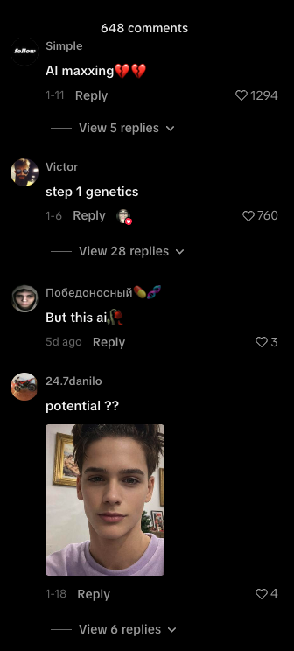
There are several critical lessons here:
Problem 1: Wrong Demographic
Looksmaxxing content appeals almost exclusively to kids aged 15 to 21. No grown adult is genuinely concerned about “looksmaxxing”. This isn't a real problem adults spend money solving.
The audience watching this content has no purchasing power. They're teenagers scrolling TikTok, not people with disposable income looking for paid solutions.
Problem 2: Wrong Platform
TikTok's core demographic is young and extremely AI-conscious. They've seen thousands of AI videos. They can spot it immediately. They call it out in the comments.
When your entire comment section is people pointing out it's AI, you've lost any chance of building trust or authority. The illusion is broken before the relationship even starts.
Problem 3: No Monetization Path
This account has no link in bio. No funnel. No offer. Because there's nothing to sell to this audience.
What would the offer even be? A looksmaxxing community for teenagers with no money? It doesn't work.
An app could possibly work, but the audience is too AI Conscious which would really hurt conversions…
Problem 4: Unsustainable
The creator hasn't posted in weeks. Why? Because they realized it was going nowhere. The content went viral, but it led to nothing. No revenue. No business. Just vanity metrics.
that’s also the #1 way to know a niche is dead, if the vids are going viral but they stop posting… if they were making $ they would keep posting.
The comments are flooded with AI callouts. The content has been exposed. People see through it. There's no path forward… especially on tiktok
The Core Mistake:
Picking a niche that attracts the wrong demographic (kids with no money) on the wrong platform (TikTok where everyone is AI-aware) with no clear problem that people will pay to solve.
Could this concept work?
Maybe. If you completely repositioned it for an older demographic (30 to 50-year-old men concerned about aging and appearance) and moved it to Facebook or YouTube where the audience is less skeptical, you might find an angle.
But as executed, this is a perfect example of viral content that generates zero business value.
Millions of views. Zero revenue. Weeks of work. Nothing to show for it.
This is what happens when you chase virality without thinking about monetization. When you pick niches based on what's trending rather than what converts. When you target demographics that can't or won't pay you.
Don't waste your time building something like this. The goal isn't to go viral. The goal is to build a business that generates real revenue from people who actually need what you're offering and have the means to pay for it.

Concepts That Are Printing $100K+
Facebook Account: secretsofhealthyliving
Link: https://www.facebook.com/profile.php?id=61584265591734&sk=reels_tab
This is a perfect example of a niche and AI influencer that's working extremely well with a hyper-targeted audience.
The Setup:
The character is a vibrant 100-year-old woman who claims to look young because of her health practices. She gives health advice specifically focused on longevity, gut health, brain health, and looking younger at an older age.
She promotes beetroot supplements and shares wellness tips targeted directly at older adults who want to age better.
Why This Works:
Right Demographic:
They're targeting older people on Facebook. Specifically older millennials and boomers (50 to 70+). This audience has money. They're concerned about aging and health. They actively seek solutions to feel better and live longer.
Right Platform:
Facebook is perfect for this demographic. The audience there is less AI-aware. They consume content based on value, not whether it's "real" or not.
Right Messaging:
A 100-year-old woman who looks 60 giving health advice is the perfect authority figure for this niche. The character herself represents the transformation the audience wants (aging well, staying healthy, looking younger).
Hyper-Specific Problem:
Not just "health advice" but specifically targeting people worried about aging, digestion, energy levels, and longevity. The content speaks directly to their fears and desires.
Now Here's What You Might Be Thinking:
"Wait, these videos are so obviously AI. The voice isn't even that good. You can totally tell it's fake."
You're right. You can tell.
But you're not the target audience.
Look at the comments. It's full of older women saying things like "Thank you for this advice," "I needed to hear this today," "You're an inspiration," "Where can I get the supplement you mentioned?"
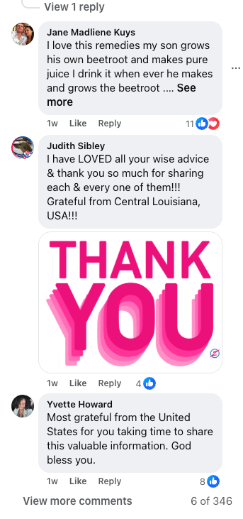
They think she's real. They don't know it's AI. And even if some do, they don't care because the advice is valuable to them.
This audience isn't analyzing pixels or listening for robotic voice patterns. They're listening to the message. And the message resonates.
The Business Model:
Right now, this account is doing affiliate marketing for beetroot supplements. Simple, effective, easy to execute.
But this same concept could work with:
- A paid community ($49/month for the "Longevity Collective")
- An info product (30-day digestion support blueprint for $47)
- Upsells and courses on aging gracefully
The affiliate route is just the easiest starting point. Put the link in the description, people buy, they make commissions. No product creation required.
The Results:
This account was created in late November. Its Januarary, That's less than two months ago
It already has hundreds of thousands of followers and millions of views on facebook..
Why? Because the content is structured well. The messaging makes sense. The niche is perfect. The demographic is right. The platform is ideal.
Everything aligns.
Compare This to the Looksmaxxing Example:
Looksmaxxing account: Targeting kids with no money on TikTok where everyone knows it's AI. No monetization. Account died.
Health longevity account: Targeting older adults with money on Facebook where they don't detect AI. Clear monetization. Account thriving.
Same technology. Completely different outcomes.
The Lesson:
This is what a well-executed AI influencer looks like.
It's not about having the most realistic videos. It's not about fooling everyone. It's not about chasing virality.
It's about:
- Picking a niche where people have a real problem
- Targeting a demographic that will actually pay to solve it
- Choosing a platform where your content can thrive
- Creating messaging that speaks directly to their pain
- Building a clear path to monetization
Do that, and the "quality" of your AI becomes secondary. The value is what matters.
This account proves you don't need Hollywood-level production. You need the right strategy, the right audience, and the right message.
That's what converts.

The Shift You Need to Make
Stop thinking like a content creator. Start thinking like a business owner & marketer
Content creators chase views and virality. Business owners solve problems and build offers.
Before you create your character, before you write a single script, before you generate a single video, ask yourself:
"What specific problem am I solving for what specific type of person?"
And then ask:
"What demographic am I targeting, and do I have the quality to reach them?"
If you're targeting 30+, you have more room for error. The quality bar is lower. The audience is more forgiving. The purchasing power is higher.
If you're targeting under 30, your quality needs to be elite. The audience is more skeptical. The platforms are harder. The monetization is more challenging.
Start with the easier path. Target older demographics. Solve real problems.
Once you've proven the model works, you can expand from there.

